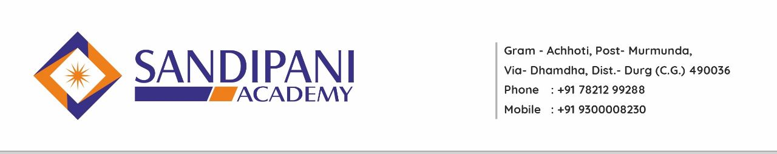
Program: B.Sc. B.Ed.
Program Learning Outcome

B.Sc.B.Ed (Integrated Bachelor of Science - Bachelor of Education) is a teacher training program. Candidates, who complete this course, are qualified to teach at secondary and senior secondary schools in the Indian schooling system and to acquire a job, they should pass relevant aptitude tests. B.Sc. B.Ed. the course has been created remembering the requirements of 12th pass students with science subjects. B.Ed. in its independent form, can be pursued only after completing graduation.
- A student can pursue a single teacher training course directly after class 12th with science subjects or can apply separately for a teacher training course after graduation.

- The course comprises of B.Sc. program just as B.Ed. program. Both the courses are joined to frame an integrated course. Hence, students won’t have to apply independently for B.Ed.

- The integrated B.Sc.B.Ed course continues for a time of 4 years only. The incorporated program is a double degree in nature. Toward the completion of the course, graduates will be granted two degrees – A bachelor’s degree (selected by the student) and B.Ed. degree. Obtaining 2 degrees within 4 years is an excellent arrangement.

- Along with the advantage of saving 1 year, it will assist one with saving money likewise as the fee of each college increases each year and if one takes admission in B.Ed. after 3 years then the expense for the same will be moderately high then the expense of B.Ed. integrated.

After the completion of this program student teachers will be able to:
- After completing B.Sc. B.Ed. Degree, students can get employed in nonscientific sectors in addition to scientific sectors. They can also get employed in forestry, horticulture, research laboratories, and government, corporate.
- This course forms the basis of Science and education for coherent understanding of the academic field to pursue multi and inter-disciplinary science careers in future.
- These subject areas include Physics, Chemistry, and Mathematics, Botany and Zoology & Education as well.
- Able to plan execute experiments or investigations, analyze and interpret data information collected using appropriate methods.
- This course heightens students in the field of innovations and developments in Science and Technology.
- They will also opt teaching as their profession.
- They will pursue higher education as MSc. M.Ed. and Ph.D. in education.
- They will become counselor and mentors.
- Recall and recognize some educational terminology, educationists, psychologists, some basic concepts, definitions of education, learning, teaching etc. Understand basic concepts and ideas of educational theory.
- Comprehend the role of the systems of governance and structural – functional provisions that support school education.
- Develop understanding about teaching, pedagogy, school management and community involvement. Build skills and abilities of communication, reflection, art, aesthetics, theatre, self-expression and ICT.
- Applies the knowledge in the course of teaching in the schools.
- Applies various methods, strategies and approaches while teaching a lesson.
- Uses the techniques learnt during the programme in the profession.
- Synthesize new methods, strategies, theories on the basis of the knowledge gained during the progamme.
- Appreciates the contributions of philosophers, educationists and sociologists for the
development of educational theory and practice.
- Uses the ICT widely in all spheres of educational theory and practice
- Appreciates the role of ICT in making the educational more reachable, making the concepts easy, catering to the needs of the individual learning at their own pace.
- Develops the skill in both micro-teaching and macro teaching.

